BiílaInstituteofTechnologyhScience,Pilani WoíkI⭲tcoíatcdLcaí⭲i⭲oPíooíammcsDivisio⭲ Scco⭲d Scmcstcí 2022-2023
Mid-Scmcstcí"cst(EC-2Rcoulaí)
CourseNo.:AIMLCZG512 |  | CourseTitle:DeepReinforcementLearning
NatureofExam:OpenBook | Weightage:30% | No.ofPages=2; No.OfQuestions=4;
Duration:2Hours; |  | DateofExam:23-07-2023 (FN)
NotetoStudents:
- Answerallthequestions.Allpartsofaquestionshouldbeansweredconsecutively.Each answer should start from a fresh page.
- WriteanswersneatlyinA4papers,scanandupload.
- Writeyournameandsignattheendofallthepages.
- Assumptionsmadeifany,shouldbestatedclearlyatthebeginningofyouranswer.
- RefertotheHonorCodepublishedatthecoursepage.

Q1)Answerthefollowingquestions.[DRLExamQuestion1;22-July-2023]

  - Consider theproblemoflearningoptimalvaluesthatcontroltraffic signals at a zebra crossing. The amount of time pedestrians wait for the signal (red), and the amount of time they get whilecrossing the road (green) are adequate to control the traffic. Provide a MDP formulation to this scenariowithallthenecessary details.Explain all the design choices. [3.5 M]
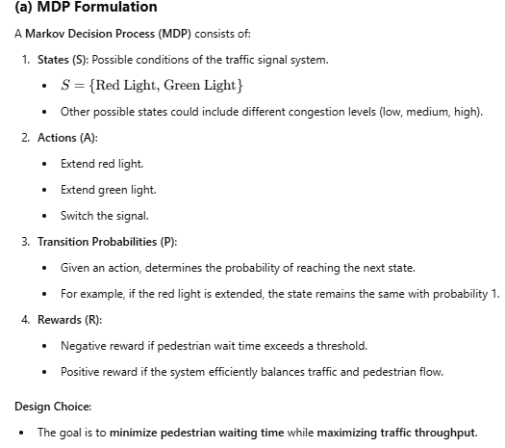
  - Write the bellman state-value equation foryourMDPin(a).Show the corresponding back-up diagram. [2.0 M]
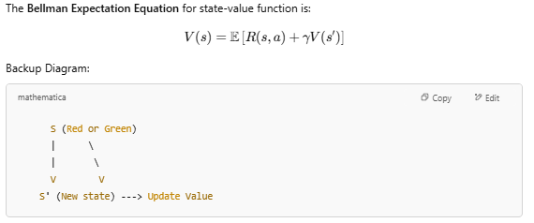
  - For the given formulation, which of the approaches to solving MDP is appropriate. Explain. [1.0 M]

  - Explain what happens if all the rewards in (a) are multiplied by 10? [1.0M]
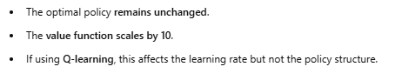

Q2)Considering Netflix's personalised video recommendation for an individual, where Netflix suggests a genre from the available list of genres (∊ {a, b, c, d}) and observes the reward (satisfactory rating) ∊ {0, 1, 2, 3} from the individual, let's analyse the following sequence of tried genresandrewards:1:(a,2),2:(b,3),3:(c,1),4:(a,1),5:(b,1),6:(d,2),7:(b,1),8:(d,1),9:(c,3),
10: (c,3), 11: (c,1), 12: (d,1). Assuming the initial value of all the actions are the same as the last digit of your student id divided by 2, please provide answers to the following questions in this specific context. [ DRL Exam Question 2 ; 22-July-2023 ]
- (Stationarycase)Whichofthosesuggestionsareexploratoryinnatureassumingε-greedy action selection and action values are obtained by sample averages ? Why? [1.5 M]
- (Non-Stationarycase)Whichofthosesuggestionsareexploratoryinnatureassuming ε-greedy action selection and action values are obtained by weighted averages with 𝛂 = 0.5? Why? [1.5 M]
- Compare your answers to (a) and (b) and explain the difference, ignoring the assumptionon stationarity. [1.5 M]
- If we initialise all the action values to be 5, will the exploratory moves due to ε-greedy behave differently? Explain. [1.5 M]
- Assuming there are n-individuals whose likings on movies are different. How would you extend the solution based on armed bandits in this case? [1.5 M]

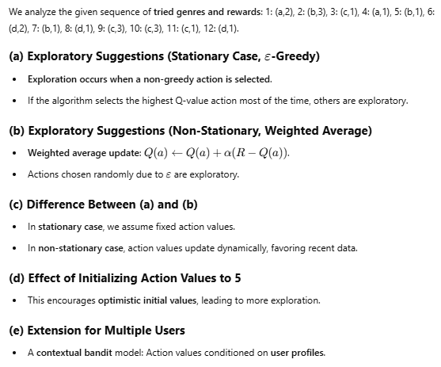

Q3)Considerarobotnavigatinginanenvironmentconsistingofsixpositions,numberedfrom0to 5.

0 | 1 | 2 | 3 | 4 | 5

At each location, the robot has two actions available: moving left (⇦) and moving right(⇒).These actions are selected with equalprobability.States0and5areconsideredterminalstates,meaning no further actions are permitted from there. When the agent transitions into state 5, it receives a reward of +x and when the agenttransitionsintostate0,itreceivesarewardof-x.xisdetermined bythelastdigitofyourstudentIDplus5.Forallothertransitions,theagentreceivesarewardof0.

Answer the following questions in this context. Use in-place version (asynchronous dynamic programming)ofthealgorithms.Thediscountfactor,𝛾is0.5.[DRLExamQuestion3;22-July-2023 ]
- Consider the values initialised to 0’s.Evaluate the following policy. Use your answer to improve the policy (i.e. one iteration). Show all the steps. [3 M]
 | ⇦ | ⇦ | ⇦ | ~
- Consider the values initialised to 0’s. Show two iterations of value iteration. Show all the steps. [3 M]
- Comment on the applicability of both the algorithms (a) & (b) for problems with large state and action spaces in no more than 3 well articulated statements. [1.5 M]
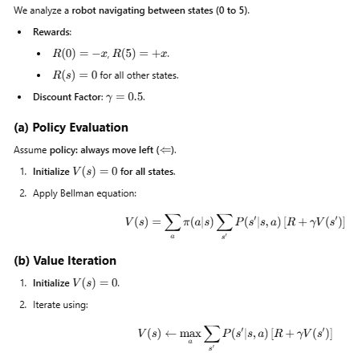


Q4)Considering Netflix's personalised video recommendation for an individual, where Netflix suggests a genre from the available list of genres (∊ {a, b, c }) and observes the reward (satisfactory rating) ∊ {0, 1, 2, 3} from three individuals { p, q, r }. It is desired to learn the most suitablerecommendationsfortheindividualsfromthefollowingepisodes{E1…E3}ofthetrialrun:

E1:p,a,0; q,c,2; p,b,0; q,c,3; r,c,2; r,b,2; q,c,1;
E2:q,b,3; r,a,2; q,c,1; p,a,0; q,a,2; p,c,2; r,b,1;
E2:r,a,2; p,b,1; p,a,2; q,c,3; q,b,3; r,a,3; q,c,0;

Assume the initial policy to be 𝝅 (p) = a ; 𝝅 (q) = a; 𝝅 (r)=c;theinitialQ(s,a)forall(s,a)are0’s; and the initial V(s) for all s to be 0’s[ DRL Exam Question 4 ; 22-July-2023 ]
- Compute first visit and every visit prediction for all the states. Whichofthesevalues converge faster to V*_{𝝅}(s)? Explain [3 M]
- Generate a random episode and find out the important sampling ratio for E2. Explain how the importance sampling ratio and model dynamics (when available) are related. [2 M]
- Explaintwoapproachesdiscussedintheclassthathelpanagentlearningpolicyusing monte-carlo methods continue exploring. [1.5M]
- Isitmandatoryfortheoff-policylearningmethodtohavenon-zeroprobabilitiesforthe choice of all actions ? Explain. [1.0M]

